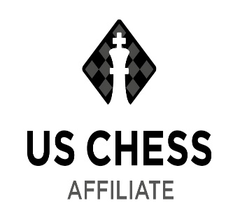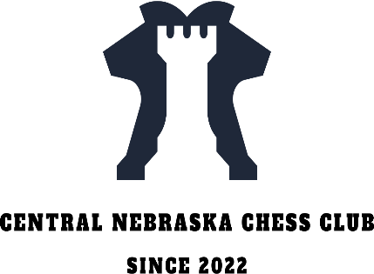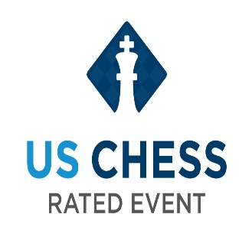
Central Nebraska Chess Club
Fall Classic Chess Tournament 2023

Saturday November 18th, 2023, 9:00am – 4:45 pm
Kearney Public Library, 2020 1st Avenue, Kearney, Ne.
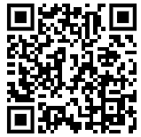
Niobrara Room, Upstairs Meeting Room

Format: USCF Section: 3 Round Swiss System
Scholastic Section: 4-6 Round Swiss System
Casual Section 4-6 Round Swiss System

Time Control: USCF Section: 40 minutes delay 5 seconds
Scholastic Section: 10 minute delay 5
Casual Section: 10 minutes

Check in and on-site Registration: 9:00 am – 9:45 am Scan QR Code to Pre-Register

https://www.signupgenius.com/go/20F054BACAA2DA4F85-45331262-central#/

Rounds: USCF Section: To play in this section, the player must have a current USCF membership. To sign up for a Membership please reach out to me centralnebraskachessclub@gmail.com at least a week before the tournament. Please be signed up before the tournament to expedite check in. We will be offering players to sign up for USCF the day of the tournament.
- Round 1 will start at 10:00 am
—Lunch—
- Round 2 will start at 12:45 pm
- Round 3 will start at 2:45 pm (Round 3 time may change)

Scholastic Section:
Round times announced at the tournament. Lunch Break will be announced too.
Scholastic Section may be divided by age based on participation.

Medals will be awarded for 1st, 2nd and 3rd Place in the USCF Rated, and Scholastic Sections.

Casual Section:
Round times announced at the tournament. Lunch Break will be announced too.

Entry Fee: USCF Section: $25
Scholastic Section: $5
Casual Section: Free

All Players and spectators including children must show proper etiquette and sportsmanship.

Contact: Eric Ring centralnebraskachessclub@gmail.com with any questions.

USCF membership- will be required for the USCF Rated Section. USCF Rules will be followed.
Half-point byes- available upon registration. Notation is required for the USCF Section

Equipment: Players are encouraged to bring their own sets and chess clocks. Limited sets and clocks might be available. Download a chess clock app from chess.com or your app store if needed.

Children: must be accompanied by a parent or guardian.

For updates about the tournament visit and follow our club on Facebook:
Central Nebraska Chess Club | Groups | Facebook
Join our Chess.com Club: Central Nebraska Chess Club
Central Nebraska Chess Club - Chess Club - Chess.com

