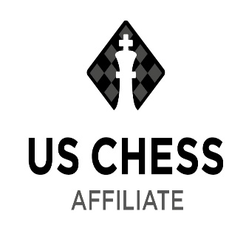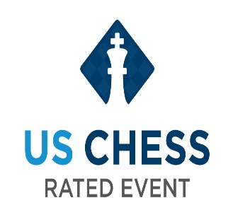
Central Nebraska Chess Club
Summer Classic Chess Tournament 2023

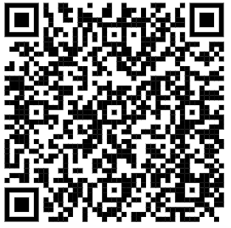
Saturday August 12th, 2023, 9:00am – 4:45 pm
Kearney Public Library, 2020 1st Avenue, Kearney, Ne.
Niobrara Room, Upstairs Meeting Room

Format: USCF Section: 3 Round Swiss System
Casual Section: 4-5 Rounds Swiss System

Time Control: USCF Section: 40 minutes delay 5 seconds
Casual Section: 25 minutes

Check in and on-site Registration: 9:00 am – 9:45 am Scan QR Code to Pre-Register

Rounds: USCF Section: To play in this section, the player must have a current USCF membership. To sign up for a Membership please reach out to me at ericring84@gmail.com at least a week before the tournament. Please be signed up before the tournament as the Tournament Director will not have time to help sign you up.
** https://new.uschess.org/form/membership **
- Round 1 will start at 10:00 am
—Lunch—
- Round 2 will start at 12:45 pm
- Round 3 will start at 3:00 pm
Medals will be awarded for 1st, 2nd and 3rd Place in the USCF Section.

Casual Section:
Round times announced at the tournament. Lunch Break will be announced at the tournament.

Entry Fee: USCF Section: $25
Casual Section: $10

All Players and spectators including children must show proper etiquette and sportsmanship.

Contact: Eric Ring ericring84@gmail.com with any questions.

USCF membership is required for the USCF Rated Section.

USCF rules will be used. Half point byes available if requested at registration.

EQUIPMENT: Players must bring their own sets and chess clocks if possible. A limited number of chess sets and chess clocks may be available. If you do not have a chess clock, you can download a chess clock app from chess.com or your app store. Notation is required for the USCF Section.

Children must be accompanied by a parent or guardian.

For updates about the tournament visit and follow our club on Facebook:
Central Nebraska Chess Club | Groups | Facebook
Join our Chess.com Club: Central Nebraska Chess Club
Central Nebraska Chess Club - Chess Club - Chess.com

